Themenblock 1: FAMILY & GENDER ISSUES

CATEGORY A: CONTRASTING IMAGES

TASK SET A1: Changing Family Roles
PART 1 — Individual Long Turn

Task:
Give a five-minute talk on changing family roles in which you
- describe, compare and contrast the two pictures above.
- analyze how traditional gender roles within families have evolved over recent decades.
- discuss whether true equality in sharing family responsibilities is achievable in today's society.
PART 2 — Paired Activity
Task:
Your school is organizing a "Modern Families" awareness week. You and your partner are on the organizing committee. Discuss the following workshop ideas and agree on three to include:
- Panel discussion with parents who have non-traditional family arrangements
- Documentary screening about how families are portrayed in different cultures
- Interactive workshop where students role-play household task distribution
- Guest speaker from a work-life balance organization
- Student survey project researching family structures

TASK SET A2: Fathers and Childcare
PART 1 — Individual Long Turn

Task:
Give a five-minute talk on the evolving role of fathers in which you
- describe, compare and contrast the two pictures above.
- analyze why expectations of fathers have changed and what has driven this shift.
- evaluate the benefits and challenges of more involved fatherhood for families and society.
PART 2 — Paired Activity
Task:
Your school is creating a video series called "Modern Parenting" for a social studies project. Discuss the episode topics below and agree on three:
- How paternity leave policies differ across countries and their effects
- Interviews with fathers about balancing career ambitions with family time
- Comparing how fathers are portrayed in advertising: then vs. now
- The rise of stay-at-home fathers: motivations and experiences
- How children benefit from having actively involved fathers

TASK SET A3: Work-Family Conflict
PART 1 — Individual Long Turn

Task:
Give a five-minute talk on work-family balance in which you
- describe, compare and contrast the two pictures above.
- analyze the causes and consequences of work-family conflict for parents and children.
- discuss the role of extended family and support networks today
PART 2 — Paired Activity
Task:
You are members of a student committee advising a local company on improving work-life balance for employees with families. Together with a workplace psychologist, you need to develop recommendations. Discuss these measures and agree on three to prioritize:
- Flexible working hours or compressed work weeks (e.g., four-day work week)
- Remote/hybrid work options with clear boundaries for 'offline' time
- On-site childcare facilities or childcare subsidies
- Extended parental leave for both mothers and fathers
- Mental health support and stress management programs

CATEGORY B: QUOTES

TASK SET B1: Work-Life Balance & Parenting
PART 1 — Individual Long Turn
Quote 1:
"I don't think women can have it all. I just don't think so. We pretend we have it all. We pretend we can have it all."
— Indra Nooyi, former CEO of PepsiCo
Quote 2:
"No one on his deathbed ever said, 'I wish I had spent more time on my business.'"
— Arnold Zack (popularized by Paul Tsongas)
Task:
Give a five-minute talk on work-life balance and parenting in which you
- critically analyze both quotes and explain what each suggests about balancing career and family.
- discuss the pressures modern parents face when trying to succeed professionally and personally.
- outline strategies that individuals and employers can implement to achieve better balance.
PART 2 — Paired Activity
Task:
Your class is contributing to a school newspaper article about how families manage work and family life. You need to prepare interview questions for parents. Discuss the topics below and agree on the four most important:
- Questions about daily routines and how household tasks are divided
- Questions about childcare arrangements and primary responsibility
- Questions about career sacrifices either parent has made
- Questions about employer support (flexible hours, home office, parental leave)
- Questions about stress management and handling pressure

TASK SET B2: Gender Stereotypes and Empowerment
PART 1 — Individual Long Turn
Quote 1:
"A woman's place is in the House... and the Senate."
— Feminist slogan
Quote 2:
"Men and women have roles — their roles are different, but their rights are equal."
— Harri Holkeri, Finnish Prime Minister & UN General Assembly President
Task:
Give a five-minute talk on gender stereotypes and empowerment in which you
- critically analyze the two quotes above and explain their significance.
- discuss common gender stereotypes that still exist today and their impact on individuals.
- evaluate progress in breaking down gender barriers and remaining challenges.
PART 2 — Paired Activity
Task:
Your school is launching a poster campaign promoting gender equality. Discuss the slogans below and agree on three that would be most effective:
- "Real strength isn't about gender — it's about character"
- "Your interests define you, not your gender"
- "Equal opportunities lead to better futures for everyone"
- "Challenge stereotypes — they limit us all"
- "Respect has no gender"

CATEGORY C: ALTERNATIVE PROMPTS

TASK SET C1: Gender Stereotypes & Domestic Work
PART 1 — Individual Long Turn
Text Extract:
"According to the European Working Conditions Survey (EWCTS 2021), women in Europe spend on average 13 hours more per week on unpaid work than men. This 'invisible workload' includes not only physical tasks like cooking and cleaning but also the 'mental load' — remembering appointments, planning meals, and organizing family logistics. When both paid and unpaid work are combined, women work approximately eight full-time weeks more per year than men."
— Adapted from Eurofound, 2023
Supporting Statistic: In Austria, mothers take parental leave for an average of 12+ months, while fathers who take parental leave typically take only 2-3 months. — Source: Arbeiterkammer/ÖIF, 2023
Task:
Give a five-minute talk on gender stereotypes and domestic responsibilities in which you
- explain what the text reveals about gender equality in the home.
- analyze possible reasons why traditional patterns persist despite societal changes.
- suggest measures that could help achieve a more equal distribution of domestic responsibilities.
PART 2 — Paired Activity
Task:
Your school wants to create an Instagram campaign challenging gender stereotypes. You and your partner are designing the content. Discuss the ideas below and agree on three:
- "Flip the script" videos showing boys cooking/cleaning and girls fixing things
- Interview clips with male students about emotions, female students about careers
- Infographics with statistics about gender inequality in Austria
- "Day in the life" stories following students who challenge stereotypes
- Quiz/poll asking followers about their own stereotype experiences

TASK SET C2: Diverse Family Structures
PART 1 — Individual Long Turn
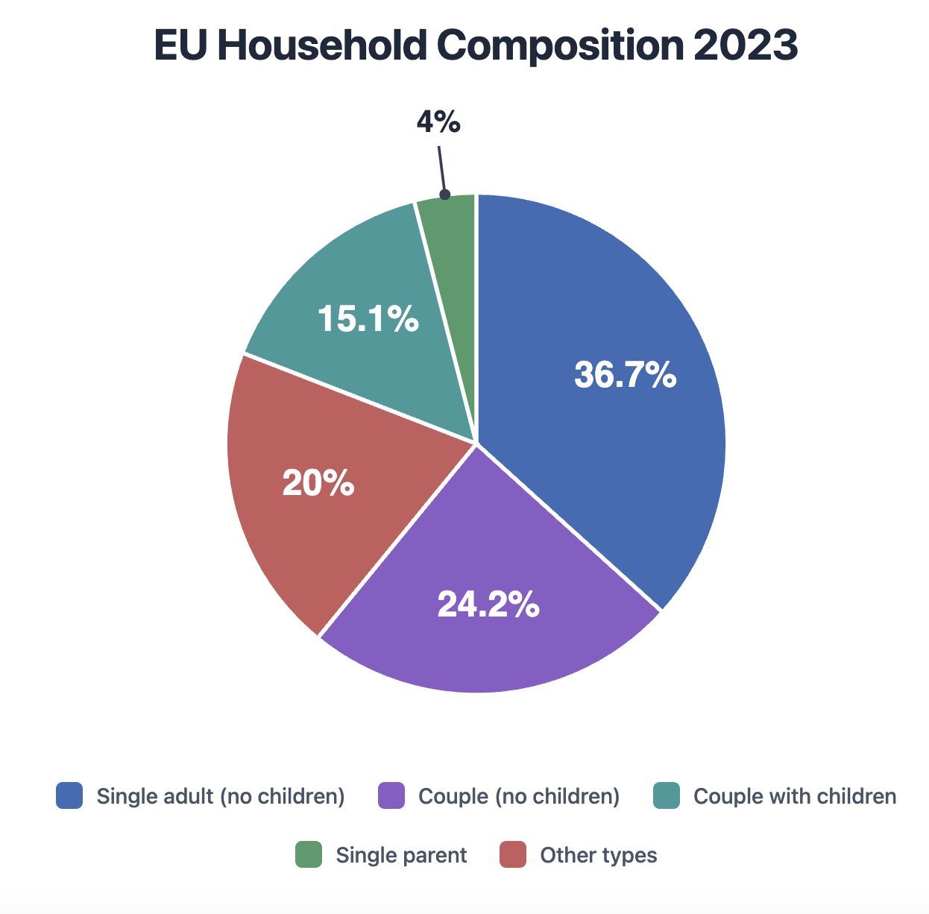

The "traditional" nuclear family — a couple with children — now represents only 15.1% of all EU households, making it smaller than single-person households (36.7%). This shift reflects changing attitudes toward marriage, later family formation, and an aging population.
Source: Eurostat EU Labour Force Survey (EU-LFS), 2023

Task:
Give a five-minute talk on diverse family structures in which you
- describe what the chart reveals about household composition in Europe.
- analyze factors that have contributed to the decline of the traditional nuclear family.
- discuss whether diverse family structures are a positive development for society.
PART 2 — Paired Activity
Task:
A family support organization wants to create resources for young people in diverse family situations.

Discuss the topics below and agree on three:
- Dealing with comments or questions about your family structure
- Building strong relationships with step-parents or step-siblings
- Managing life between two households after parents separate
- Finding support and community with families like yours
- Celebrating your family's unique strengths and qualities

